Step1:- Activate the JDBC driver software by registering jdbc driver software at DriverManager service.

Oracle.jdbc.Driver.OracleDriver driver=new Oracle.jdbc.Driver.OracleDriver();

DriverManager.registerDriver(driver);

Step2:- Establish Connection with DB s/w from Java application.

DriverManager.getConnection(“DatabaseUrl”,“Uname”,”pwd”);  
 This method establish the connection between java app and local DB s/w or Remote DB s/w. It returns Connection Object or null to Java application. Connection Object represent connection between java application and Database software. If connection is established then connection object is returned otherwise null is returned.

Step3:- Create a Statement Object to send SQL queries to DB s/ws from java application and

To bring output from DB s/w to Java application.

Step4:- send and Execute the SQL queries by DB s/w using Statement object.

Step5:- Gather SQL query output from DB s/w and process it using statement object.

Step6:- close the connection.

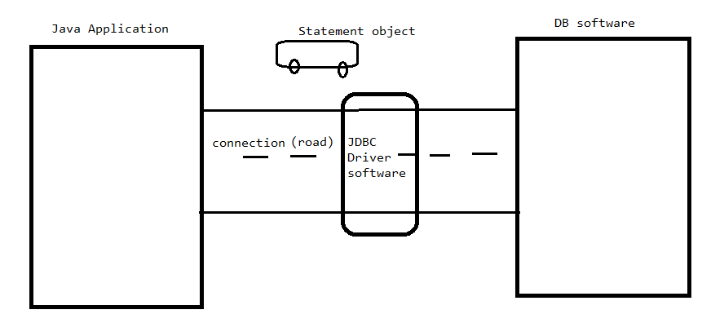

Where connection acts as road.

Statement object acts as vehicle for carrying the sql queries and query result.

Note:- one day or another day, the DB software may reach to max connections. Although all connections are in idel state, new application can’t connect with db. So It is recommended to make every app to close the connection at the end of utilization.

Example:1 Program demonstrates establishing connection between java app and DB s/ws.

import java.sql.\*;

public class ConnectionDemo{

public static void main(String args[])

{

try{

oracle.jdbc.driver.OracleDriver driver= new oracle.jdbc.driver.OracleDriver();

Connection con=DriverManager.getConnection("jdbc:oracle:thin:@localhost:1521:XE","sukumar","sukumar");

if(con==null)

System.out.println("Connection not Established");

else

System.out.println("Connection established");

}

catch(Exception e){

System.out.println(e.getMessage());

}

}

}

Output:-

